Network Traffic Inspection &
Rogue Service Detection System
Information Security Lab — Final Project Report
4th Semester

Submitted To: Course Instructor
Department of Computer Science
Date: June 7, 2026

1. Introduction
This project was built for the Information Security (IS) Lab as a practical demonstration of the CIA Triad — Confidentiality, Integrity, and Availability. Instead of just reading about these concepts, we actually built a working system that shows what happens when security is missing and what happens when it is properly applied.
The project is split into two main parts. Module A deals with network traffic — it shows how a password typed into a plain HTTP website can be read by anyone on the network, and then demonstrates how switching to HTTPS completely hides that same password. Module B is a network scanner and auditor — it automatically scans a network, finds every open service running on machines, and raises an alert if any dangerous or unauthorized service is found.
Everything runs from a single, polished terminal dashboard called NITDS (Network Inspection and Threat Detection System). The dashboard was built using Python and the 'rich' library, giving it a clean, colour-coded interface with live status indicators.
1.1 Objectives
- Show the real danger of sending passwords over plain HTTP (no encryption).
- Show how TLS/HTTPS fixes that problem — the sniffer captures nothing useful.
- Build an automated network scanner that finds all open ports and services.
- Create a policy-based engine that automatically flags dangerous services as ROGUE.
- Package everything in one easy-to-use terminal dashboard.
1.2 Tools and Technologies Used
Tool/Library | Purpose
Python 3.10+ | Core programming language for all modules
rich | Terminal UI library for the dashboard (colours, tables, panels)
Python http.server | Built-in module used to run the HTTP and HTTPS servers
ssl (Python stdlib) | Wraps the server socket with TLS encryption
OpenSSL | Generates the self-signed X.509 certificate and RSA private key
pyshark / tshark | Packet capture and dissection (Wireshark's command-line engine)
nmap | Port scanner used by the network auditor to find open services
policy.json | JSON file that defines which ports are safe and which are rogue

2. System Architecture
The project is organized into two modules, each living in its own folder, and a single controller script that ties everything together.
2.1 Project Structure
is_lab_project/
├── main_controller.py ← Central TUI dashboard (entry point)
├── requirements.txt ← pip dependencies
├── module_a_traffic/
│ ├── insecure_server.py ← TC-01: Plain HTTP server (port 8000)
│ ├── secure_server.py ← TC-02: TLS-encrypted HTTPS server (port 8443)
│ ├── generate_certs.sh ← Creates server.crt and server.key via OpenSSL
│ └── sniffer_agent.py ← Captures packets; reads creds (HTTP) or verifies TLS (HTTPS)
└── module_b_detector/
├── network_auditor.py ← Nmap engine + policy-based rogue detector
└── policy.json ← Authorized vs rogue port definitions
2.2 Main Dashboard (main_controller.py)
The main_controller.py file is the front door of the entire project. When you run it, you see a full-screen terminal interface with a banner, a live status bar, a menu, and a rolling activity log. You never need to open individual scripts manually — every action in the project is triggered from this one dashboard.
The dashboard tracks the state of all running processes (HTTP server, HTTPS server, sniffer) and shows whether they are running or stopped in real time. It uses Python's subprocess module to launch each script as a background process, reading its output and feeding it into the activity log.
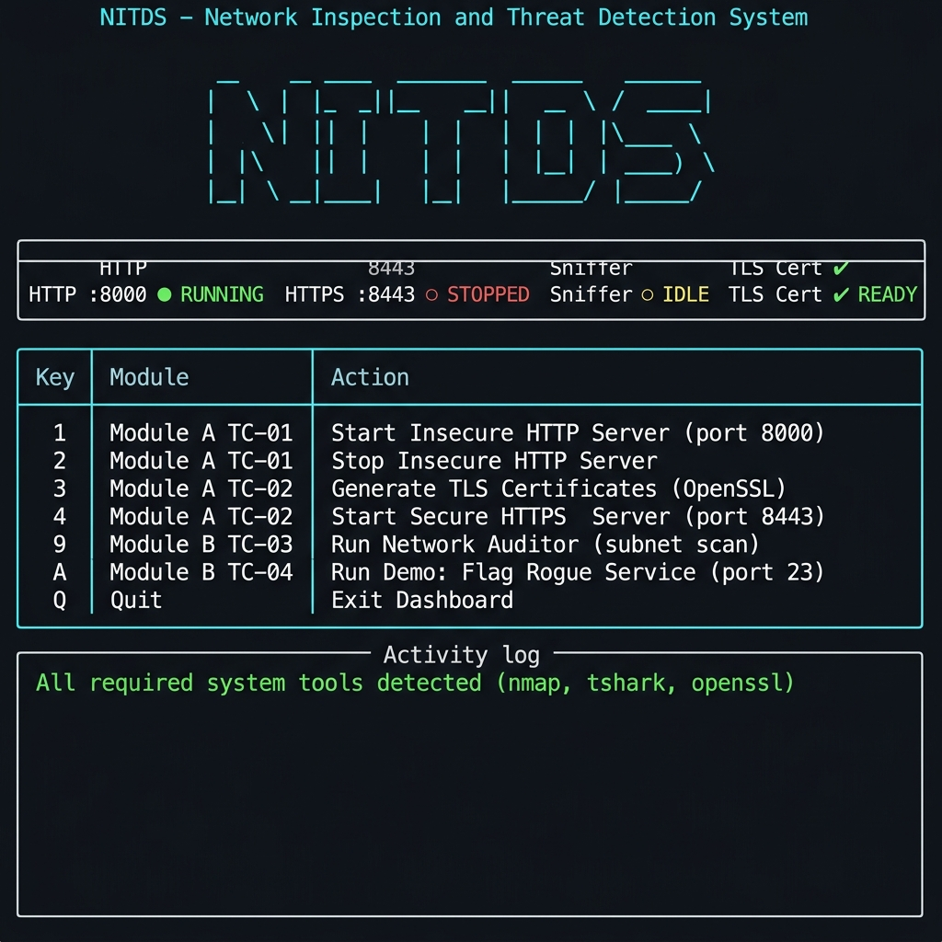
Figure 1: NITDS Main Dashboard — status bar, menu, and activity log

3. Module A — Network Traffic Inspection
Module A has one core message: if you send data over plain HTTP, anyone on the network can read it. If you send it over HTTPS, they cannot. We prove this in two test cases.
3.1 Test Case TC-01 — Insecure HTTP Credential Capture
Security Concept: Violation of Confidentiality
insecure_server.py starts a web server on port 8000 that serves a realistic-looking Instagram login page. The page is built with full CSS styling so it looks genuine. When a user types their username and password and clicks Log In, the browser sends a POST request to /login. Because there is no encryption, this POST request travels through the network as plain readable text.
At the same time, sniffer_agent.py is running in a separate process. It uses pyshark (a Python wrapper around tshark, which is Wireshark's command-line version) to listen on the loopback network interface. When the POST request arrives, pyshark reads the http.file_data field of the packet — which contains the form body — and extracts the username and password directly from it.
How to Run TC-01
# Terminal 1 — start the HTTP server:
python3 module_a_traffic/insecure_server.py
# Terminal 2 — start the sniffer (needs root for packet capture):
sudo python3 module_a_traffic/sniffer_agent.py --mode http --interface lo
# Terminal 3 — submit a login:
curl -d 'username=alice&password=secret123' http://localhost:8000/login
TC-01 Expected Output
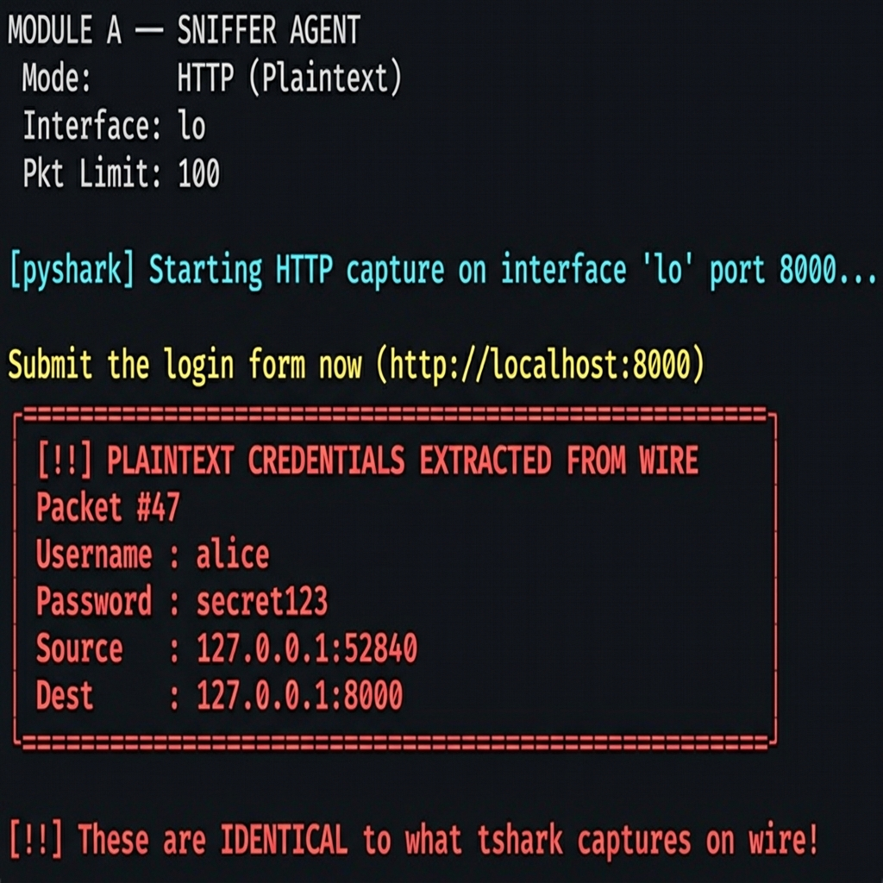
Figure 2: TC-01 — Sniffer extracts plaintext username and password from HTTP traffic
The sniffer immediately prints the captured credentials. The username 'alice' and password 'secret123' appear in full on the terminal — exactly as typed by the user. This proves that without encryption, a passive attacker on the same network can silently steal credentials without the victim knowing anything happened.
3.2 TLS Certificate Generation
Before we can run the secure server, we need a TLS certificate. The file generate_certs.sh uses OpenSSL to create a self-signed X.509 certificate and a 2048-bit RSA private key. The command used is:
openssl req -x509 -newkey rsa:2048 -nodes -days 365 \
-subj '/C=PK/ST=Punjab/L=Lahore/O=IS-Lab-Demo/OU=Security/CN=localhost' \
-keyout server.key -out server.crt
This creates two files: server.key (the private key, kept secret on the server) and server.crt (the public certificate, shared with clients during the TLS handshake). In a real-world scenario, this certificate would be signed by a trusted Certificate Authority like Let's Encrypt. For this lab, a self-signed certificate is enough to enable and test TLS.
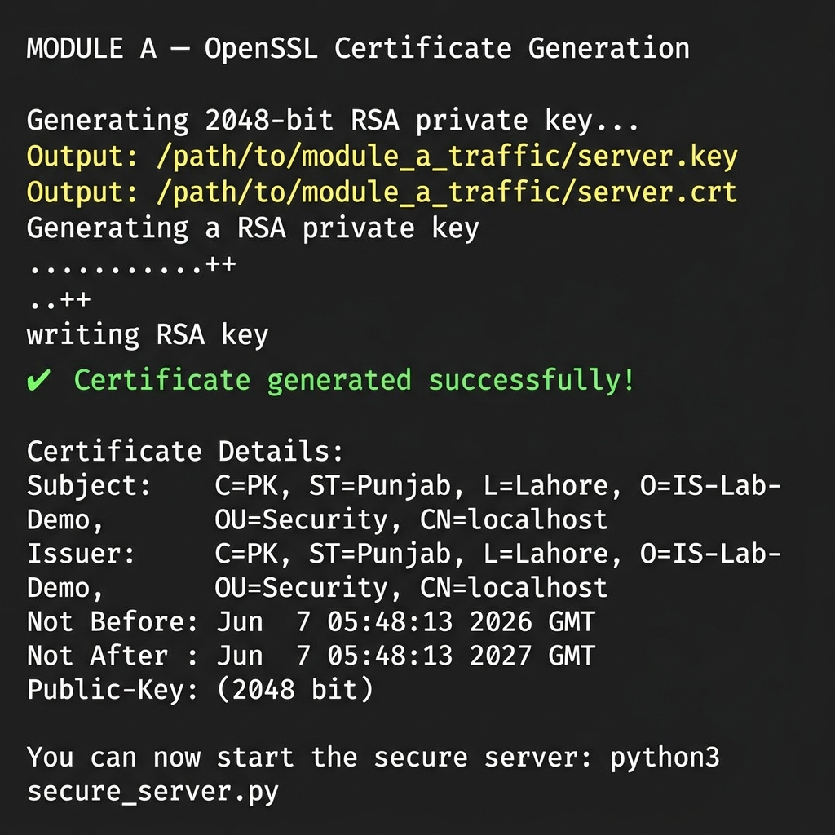
Figure 3: OpenSSL generating the RSA private key and self-signed certificate
3.3 Test Case TC-02 — HTTPS TLS Verification
Security Concept: Confidentiality via TLS
secure_server.py runs the exact same login page but on port 8443 with TLS enabled. Internally, Python's ssl.SSLContext wraps the raw TCP socket with TLS. Every byte that leaves the server is encrypted before it hits the network. The browser and server go through a TLS handshake first, after which all communication is encrypted.
We run sniffer_agent.py again, this time in HTTPS mode. The sniffer still captures every packet on the wire. But now, instead of seeing form fields and passwords, it only sees TLS record headers — CLIENT HELLO, SERVER HELLO, CERTIFICATE, APPLICATION DATA. The APPLICATION DATA packets, which contain the actual credentials, are fully encrypted. The sniffer can see that a packet exists, but cannot read its contents.
How to Run TC-02
# Step 1 — generate certificates (only needed once):
bash module_a_traffic/generate_certs.sh
# Terminal 1 — start the HTTPS server:
python3 module_a_traffic/secure_server.py
# Terminal 2 — start the sniffer in HTTPS mode:
sudo python3 module_a_traffic/sniffer_agent.py --mode https --interface lo
# Terminal 3 — send a login:
curl -k -d 'username=alice&password=secret123' https://localhost:8443/login
TC-02 Expected Output
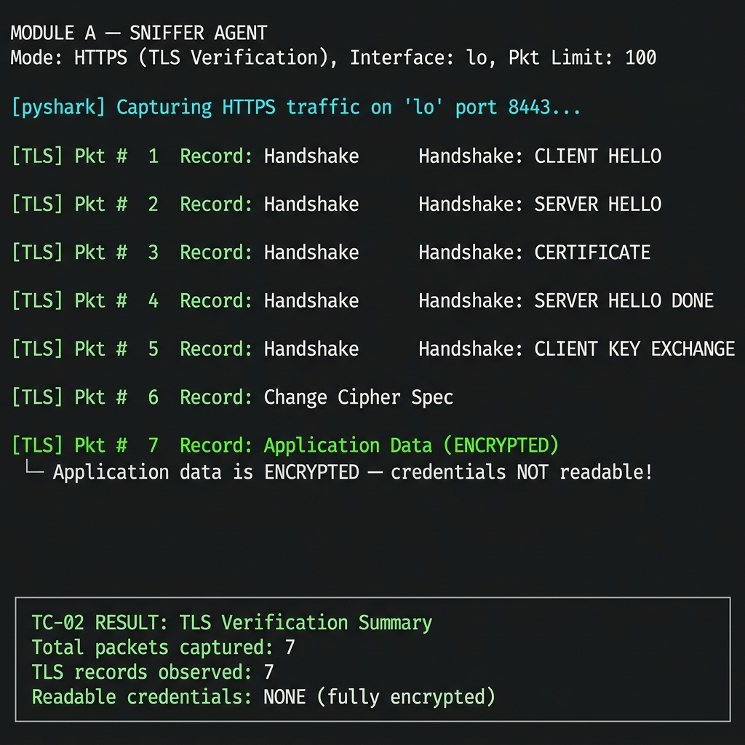
Figure 4: TC-02 — Sniffer sees only TLS handshake records; credentials are fully encrypted
The sniffer output shows packets labelled Handshake, Change Cipher Spec, and Application Data (ENCRYPTED). Notice that the username and password never appear anywhere in the output. The final summary confirms: Readable credentials: NONE. This is TLS working exactly as it should.

4. Module B — Rogue Service Detection
Module B addresses a different security problem: how do you know what is actually running on your network? Attackers often install backdoors or leave dangerous legacy services running. Module B automates the discovery and flagging of such services.
The module has two components: network_auditor.py (the scanner and analyser) and policy.json (the rulebook that defines what is safe and what is not).
4.1 The Security Policy (policy.json)
policy.json is a simple JSON file that lists two categories of ports. Authorized ports are services that are known, approved, and secure. Rogue ports are services that should never be running — either because they send data in plaintext (like Telnet and FTP) or because they have no authentication.
Port | Service | Status | Risk | Reason
22 | SSH | AUTHORIZED | None | Encrypted remote shell — approved
443 | HTTPS | AUTHORIZED | None | Encrypted web — approved
8443 | HTTPS-alt | AUTHORIZED | None | Lab HTTPS server — approved
53 | DNS | AUTHORIZED | None | Name resolution — approved
21 | FTP | ROGUE | HIGH | Cleartext file transfer
23 | Telnet | ROGUE | CRITICAL | Cleartext remote shell
80 | HTTP | ROGUE | HIGH | Unencrypted web traffic
8000 | HTTP-dev | ROGUE | MEDIUM | Dev HTTP server, no encryption
110 | POP3 | ROGUE | HIGH | Cleartext email retrieval
69 | TFTP | ROGUE | HIGH | No authentication, no encryption
4.2 How the Auditor Works
network_auditor.py works in five steps every time it runs:
- Step 1 — Load policy: reads policy.json to know which ports are authorized and which are rogue.
- Step 2 — Host discovery: runs 'nmap -sn' (ping scan) against the target subnet to find live machines.
- Step 3 — Service scan: for each live host, runs 'nmap -sV' to enumerate every open port and detect the software version running on it.
- Step 4 — Policy check: compares each open port against the policy. Ports in authorized_ports get a green SAFE label. Ports in rogue_ports get a red ROGUE label with risk level. Anything not in either list gets flagged as UNKNOWN for manual review.
- Step 5 — Report: prints a formatted per-host report and a final summary showing all critical findings.
4.3 Test Case TC-03 — Subnet Discovery and Port Listing
Security Concept: Threat Detection through Visibility
TC-03 demonstrates the basic audit flow. We scan the localhost (127.0.0.1) to see what services are currently running. The --skip-discovery flag tells nmap to skip the ping scan (not needed for a single known IP) and go straight to port scanning.
How to Run TC-03
python3 module_b_detector/network_auditor.py --subnet 127.0.0.1 --skip-discovery
# To scan a VM subnet instead:
python3 module_b_detector/network_auditor.py --subnet 192.168.56.0/24
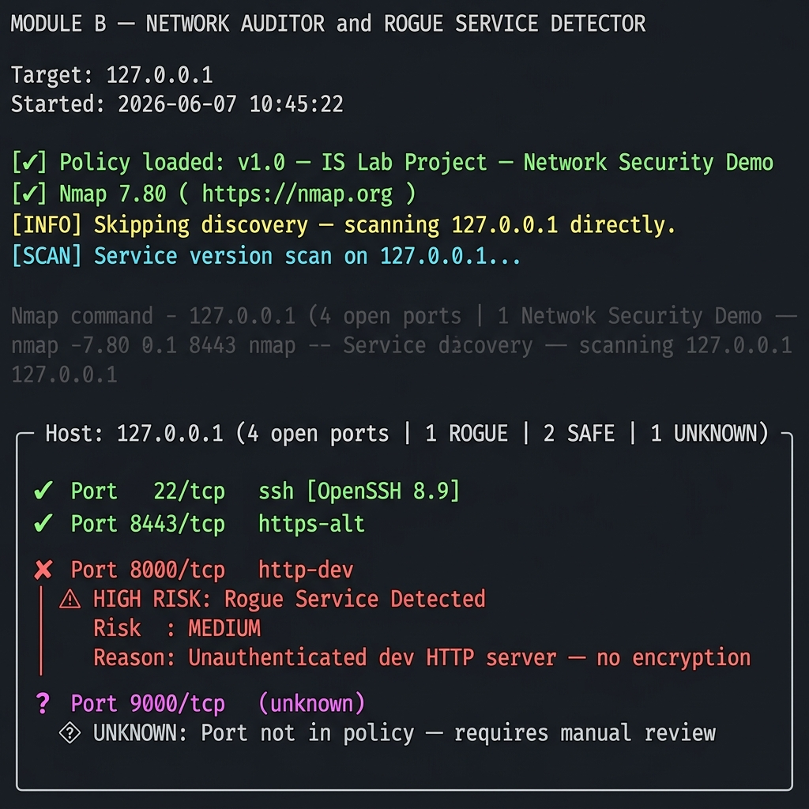
Figure 5: TC-03 — Network audit showing safe ports and a flagged rogue HTTP server
The output shows each open port with a coloured label. Green checkmarks mean the service is authorized. Red X marks mean a rogue service was found. Port 8000 (our insecure HTTP server from TC-01) is correctly flagged as MEDIUM risk because it runs without encryption.
4.4 Test Case TC-04 — Rogue Service Flagging (Telnet on Port 23)
Security Concept: Automated Threat Identification
TC-04 simulates a real attack scenario: a rogue Telnet service has been started on the machine. Telnet is one of the most dangerous legacy protocols — it sends everything, including login credentials and all commands, in complete plaintext. Any attacker on the same network can hijack the entire session.
The demo works in four automatic steps. First, the dashboard opens a netcat listener on port 23, simulating a rogue Telnet backdoor. Then it runs the network auditor against localhost. The auditor finds port 23 open and compares it against the policy, which marks Telnet as CRITICAL risk. A big red alert is printed. Finally, the rogue listener is automatically killed and cleaned up.
How to Run TC-04
# Use the dashboard (option A) which automates everything:
python3 main_controller.py → press A
# Or manually:
sudo nc -lvp 23 &
python3 module_b_detector/network_auditor.py --subnet 127.0.0.1 --skip-discovery
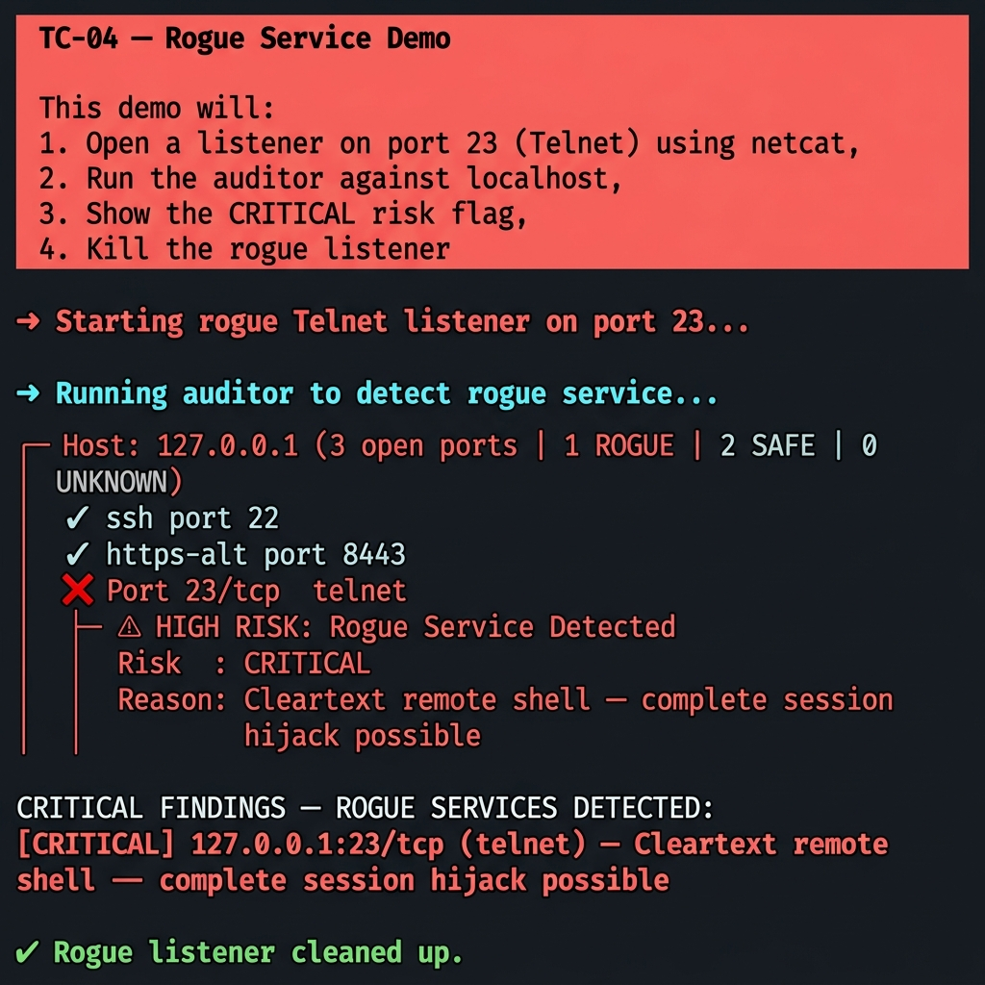
Figure 6: TC-04 — Rogue Telnet service on port 23 flagged as CRITICAL risk
The output clearly shows the CRITICAL finding with the reason: Cleartext remote shell — complete session hijack possible. This is exactly what a real security audit would report. The auditor then prints a final summary listing every rogue service found, making it easy for a system administrator to take action.

5. Security Concepts Demonstrated
CIA Principle | Where Demonstrated | How
Confidentiality (violated) | TC-01 — HTTP sniffer | Credentials captured in plaintext from unencrypted HTTP traffic
Confidentiality (enforced) | TC-02 — HTTPS with TLS | Same credentials become unreadable on the wire after TLS is applied
Integrity | TC-02 — TLS MAC/AEAD | TLS prevents any in-transit modification of packets
Identity / Authentication | TLS Certificate (OpenSSL) | Server certificate proves server identity to the client
Threat Detection | TC-03 — Nmap scan | Automated port scan reveals the full attack surface of a host
Vulnerability Assessment | TC-04 — Policy engine | Policy flags legacy cleartext protocols as HIGH or CRITICAL risk

6. Results Summary
Test Case | Module | Goal | Result
TC-01 | A | Capture credentials over plain HTTP | PASS — username and password captured from wire in full plaintext
TC-02 | A | Verify TLS hides credentials | PASS — only TLS handshake visible; no credentials readable
TC-03 | B | Discover hosts and list open ports | PASS — all open ports listed with service names and versions
TC-04 | B | Flag rogue service (Telnet port 23) | PASS — port 23 flagged CRITICAL; reason printed in report
Key Observations
- HTTP is fundamentally insecure for any login form. The sniffer required no special attack — it simply read packets that were already visible on the network.
- Adding TLS required only three things: a certificate, a private key, and wrapping the socket with ssl.SSLContext. The application code did not change at all.
- Automated network auditing provides a huge advantage. Instead of manually checking each machine, the auditor scans the entire subnet and flags every problem in seconds.
- The policy.json approach is flexible and realistic. In a production environment, security teams maintain exactly this kind of allowlist/denylist policy.

7. Conclusion
This project successfully built a working, hands-on demonstration of core information security concepts. Rather than just describing threats in theory, we built real tools that show the threat happening and then show the fix working.
Module A proved that plain HTTP offers zero protection for user credentials. Any passive listener on the network — whether a legitimate network admin, a lab tool, or a malicious attacker — can read usernames and passwords without any effort. Switching to HTTPS with even a self-signed certificate completely eliminated that risk. The sniffer went from capturing full credentials to capturing nothing of value.
Module B showed that visibility is the first step in security. You cannot protect what you do not know exists. The automated auditor, combined with a clear policy definition, makes it straightforward to find dangerous services like Telnet and FTP and raise an alert before an attacker can exploit them.
Together, these two modules form a practical mini security toolkit that reflects real-world practices: network traffic inspection, TLS enforcement, port scanning, and policy-based vulnerability assessment.

8. References
- Python Software Foundation. ssl — TLS/SSL wrapper for socket objects. https://docs.python.org/3/library/ssl.html
- Nmap Network Scanning — The Official Nmap Project Guide. https://nmap.org/book/
- RFC 5246 — The Transport Layer Security (TLS) Protocol Version 1.2
- RFC 8446 — The Transport Layer Security (TLS) Protocol Version 1.3
- Wireshark / tshark Documentation. https://www.wireshark.org/docs/
- OpenSSL Documentation. https://www.openssl.org/docs/
- Willems, C. et al. (2012). Towards automated network security analysis. Security and Communication Networks.

